The Color of Love

The Color of Love

Gyana Pendleton

Copyright © 2023 by Gyana Pendleton

All rights reserved. No part of this publication may be reproduced, distributed, or transmitted in any form or by any means, including photocopying, recording, or other electronic or mechanical methods, without the prior written permission of the authors, except in the case of brief quotations embodied in critical reviews and certain other noncommercial uses permitted by copyright law.

Printed in the United States of America

ISBN: 9798373200455

Contents

Forty Years . . . . . . . . . . . . . . . . . . . . . . . . . . . . 1

Woodpecker: Searching for Enlightenment. . 4

The Color of Love . . . . . . . . . . . . . . . . . . . . . . .8

Beloved . . . . . . . . . . . . . . . . . . . . . . . . . . . . . . 10

The Password . . . . . . . . . . . . . . . . . . . . . . . . . 12

Compassion . . . . . . . . . . . . . . . . . . . . . . . . . . .14

Life on the Land . . . . . . . . . . . . . . . . . . . . . . . 16

Good-byes . . . . . . . . . . . . . . . . . . . . . . . . . . . .18

On the Road to Santa Fe . . . . . . . . . . . . . . . . 19

Several Days on Earth . . . . . . . . . . . . . . . . . . 20

The Nose . . . . . . . . . . . . . . . . . . . . . . . . . . . . 23

Katie . . . . . . . . . . . . . . . . . . . . . . . . . . . . . . . . 25

*Dedicated to my two beloved children*

*who taught me so much about love.*

*Acknowledgements*

*Special thanks to my wonderfully kind and patient editor, Phaedra Greenwood, without whom these poems would never have seen the light of day. Salud! Salud! Thanks also to Alexander Levy, for the elegant, original book design.*

Forty Years

Forty years come and gone

Forty years of clay-covered hands

Dipping into and out of the warm and wet slip

Of clay and water.

Those years of centering clay upon the wheel

The wheel of my life as well

Collaborating with the clay

Learning the pitfalls of forcing

My way.

Forty years give or take a few

Of being partner in the metamorphosis

of earth into vessel.

So many years savoring the precious times

When clay and potter are one

In perfect balance, ready, waiting

To be opened to take form,

One hand pressing downwards

With just the right pressure

The other inwards, body weight behind it.

Fingertips listening for that perfect moment

To open this pyramid of earth into

Its destiny of vessel-hood.

And when opened, floor established, firmed down,

Walls beginning to rise. Forty or more years

Now of raising walls

So that beauty and capacity begin,

And always checking the treasures of balance

Perhaps stepping away to crouch down

And see the form still slowly

Spinning on the wheel evenly

Now checked by eyes as well as hands

Forty years or more.

And now, hardly breathing, pulling the walls upward

Higher

Shaping the belly of the pot slightly, delicately

Ensuring the rim is still even.

For forty years, the ecstatic final touch

Fingers on clay

Then sliding the wire underneath.

Many years, oh so carefully.

The joy of loving this vessel into existence,

Yet to be fired once

Glazed, fired again.

Forty years of celebrating the emptiness

In the center, in the curve of the vessel-to-be

Uncovering spaciousness,

Space.

Forty years, this potter’s happy privilege

Of creating

A container for space.

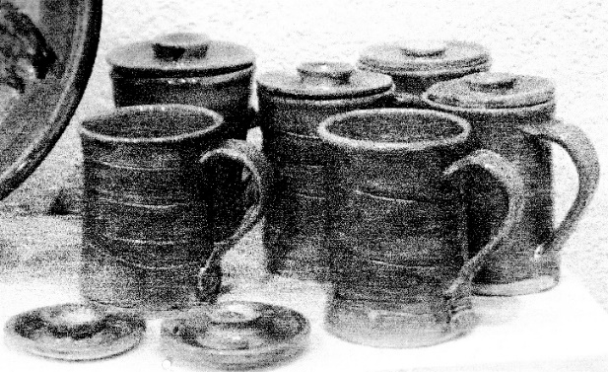

Woodpecker

Or

Searching for Enlightenment

I went to India once and stayed pretty much

for five years.

I loved my guru, his universally loving heart.

I wanted to know what he knew

So I stayed.

I knew it was not about

Knowing.

Much more it was about not knowing

But what exactly did that mean?

I wanted to know.

I met a man there who had been with our guru

Many years before.

His eyes were pools of presence

Deeply blue.

Someone profoundly there,

At the same time,

No one.

What was it like, I asked him,

To be here with Papaji

So many years ago, in the early days?

I held my breath, knowing I was about to hear of

Wondrous, mystical experiences,

Transports

Into the realm of the angels.

I waited.

We wrestled, he said,

We arm-wrestled.

Silence.

And then, what? I said.

And then, I went back home.

To Australia, he said.

But how did you convey to others this

precious experience,

This knowledge, this truth?

I didn't.

You didn’t?

He laughed.

And so did I. Laughed

And laughed. And laughed.

No more questions.

Let me just fly a kite into the heavens!

Sing “O Solo Mio” with Pavarotti

Love my friends.

Cook them delicious things to eat

Get a little drunk, laugh

Until we cry, dance the tango

Make love until the dawn.

I will adore the wild foxglove in the woods

The robin like superman leaping

Across my yard

The rabbits

Break-dancing at dusk

My dog’s gentle tongue

Tenderly licking the last bits

Of a chicken taco off my fingertips.

And oh I will weep with the beauty

In the sky

In a human being

In a poem

And I will hold my breath

As this woodpecker

Brushes her wing

Across my hair

In eloquent benediction.

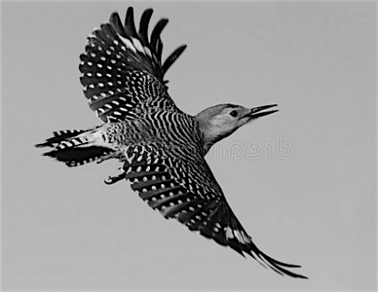

The Color of Love

The color of love is the rainbow

Every color we have seen and some

we have not seen

Until we are

There.

Green is the color of hope.

Hope for new possibilities,

Spiritual, pharmaceutical, herbal

Or otherwise.

The color of you

Diminishing, is

White tinged with the delicacy of pale rose,

Ethereal blue.

Celestial flesh

As transparent as the tiny

Hummingbird

You gave me our first Christmas.

Do you remember how we laughed

Until we cried

When I thanked you

For the tiny duck?

Your color once was blue, the vivid blue

Of your eyes

Those eyes that altered the shape

Of my life

And swept me into your heart

Nineteen years ago

Now those eyes look inward

Mostly

Although when I walk down the hall

Toward your room

Knock and open your door

For a moment or two

Those eyes I love

Are the color of happiness.

I help you up, take your arm, get the walker.

We walk down the hall, through

The lobby,

And out the front door

Into the fresh air of another day.

Beloved

*On January 16, 2020, my beloved partner, Peter Wood, passed away. Release, peace, joy now embrace him. A big man, with a big heart, an artist through and through who depicted the depth of Native peoples in New Mexico with a deep understanding and love for their ways of being.*

*For five years illness had plagued him. Eventually he was immobilized in his body, unable to move, to speak. He would still try to speak, attempting to convey his thoughts. A brave man with so much courage, so much love. A blessing to all who knew him.*

Beloved

I spread these ashes, your body,

In this sacred place where you may rest

In peace, in quiet,

The very qualities that are in

Your loving heart, your soul.

In these mountains which you loved dearly

May the wildlife bless you

With their presence

As your presence blesses them.

May your soul fly

On the wings of birds

As well as of angels

Vaya con Dios My Beloved.

Vaya con Dios

The Password

“Please enter your four-digit password”

The voice at the other end of the line says.

“Click, click, click, click,” I enter four numbers.

“That is an incorrect password.

Please enter your password,”

The digitally not unfriendly voice says.

“Click, click, click, click.”

“That is an incorrect password.

Please enter your password.”

Oh, no, isn’t this my password?

Then what is it?

And is it for Verizon? Apple?

For Taos Net?

“Breathe,” I tell myself.

“Which self is telling which self?”

“Let’s try again,” we all agree.

Now I’ve forgotten who I was calling.

Is there a place I can run to

Where I don’t need a password?

“Please, sweet Lord,

You have answered my prayers before,

So lovingly. Here

Is one more I ask of you.”

“Breathe,” is God’s answer.

Or is it my password?

Compassion

“Compassion for someone

On the other side of my “truth” is not easy.

Sweet Jesus!

Compassion for one who murders? Putin

Compassion for greed taken to new heights? Trump

I’m tryin’ lord tryin’ hard.

Can this observer

And perhaps you too

Be another Thich Nhat Hahn,

Knowing that she is the rapist

As well as the girl raped

And thrown overboard?

Knowing that she is the twister of facts

The presidential liar

As well as

The defender of democratic principles and ideals?

Of ethical behavior, for example honesty?

The sun is just now

Coming up

over

the

hill.

Can this be happening at the same moment

As the machinations of fascism

Are slowly being put into place in our country,

In what is left of our democracy? Has dishonesty

Become our new morality?

Is my outrage,

My tears spilled on the page

My gut clenching in disbelief

As I write about these things

Because I am an elitist?

Should I perhaps see the truth in alternate facts?

Is insanity the new measure of truth?

Life on the Land

1982-1986

Memories of life on “the land” are precious. They are memories of a life lived with joy and hard work. Laughter, and backaches, tears and love.

It was getting close to quitting time. It was Eastern Oregon, 1983 or 1984, “The Ranch” as we called it. The sky was beginning its transformation from clear blue to delicate rose, deepening red, and finally velvet blue. We — all of us amateur construction workers who'd never built anything more than houses out of building blocks — were hungry, tired, headed for the cafeteria, a glass of wine, and dinner. And sleep!

Out of nowhere came the strands of a Strauss Waltz filling the central Oregon air with wonder. Young bodies threw off their fatigue and muscle aches, their tired backs as well as backpacks. Threw all that off, grabbed each other, and danced! Waltzed! Into Oregon dusk we danced and danced. As we danced, the office workers across the road all came out to watch.

Twirling, laughing, there we were, dancing our hearts out in the dry Oregon desert to the music of a Strauss Waltz.

Some years later, in remembering those years on the commune, my companion told me that he was one of those observers, standing watching us dancing, tears running down his cheeks, tears of joy and love.

In those moments, we were all filled with a tenderness for each other, almost more than we could express. So we danced! Danced and danced to the magic of our hearts, until our hungry bellies said “Stop!” Time to eat. So we stopped, walked up to the cafeteria and ate.

Never again would we hear Strauss Waltzes without remembering our dancing as the sun went down on that beautiful place we called The Ranch.

Good-byes

The light of day is bright, is practical.

Beautiful

We live by it.

The evening light is a poem.

deep, glowing, fading.

A holy good-bye to the day.

It rests for a moment

On hillsides,

Lifting them up

Into such presence

That every crack

Every “imperfection” is glorified.

The evening light is a leave-taking of the day.

The soul’s song, a good-bye.

All good-byes are holy.

On the Road to Santa Fe

A hospice patient had died in the night. I was asked to transport the body down to the crematorium in Santa Fe, about a one-and-a-half-hour drive. It was a logical request, since I had a little pick-up truck, perfect for the task.

So, here we were — on the road to Santa Fe, our patient’s wife in the passenger seat, my beloved dog, Sita, in the truck with us and in the bed of the truck, the body of our hospice patient, wrapped in a blanket.

The patient’s wife, out of nervousness, was talkative, Sita-dog my adorable white lab mix dog curious, beautiful, and me, the driver probably all of us in a state of semi-shock. And of course, the wrapped body of our patient, now cold. And still as a rock.

When we arrived the body was carried out of the truck and into the crematorium. The flood gates opened and his wife could let her sorrow out. I, too, could now let go of some of my emotions of grief and loss in harmony with hers.

Several Days on Earth

She was going to San Francisco for a medical appointment. He was going with her because he was a good and caring man and he loved her.

Getting on the plane in Albuquerque after almost three hours of driving was easy. Arriving at the San Francisco Airport, finding the baggage, finding the train that went to the car rental, renting the car, driving off, all accomplishment. Less of an accomplishment was getting lost on the unfamiliar freeway — Hmmm, I don’t think we should be going all the way to San Jose! Finally getting to the first night's motel.

At that late hour, the only “restaurant” open was a Burger King. Eating their burgers amidst a couple of clean-up guys mopping the floors, sleeping that night, eating a free and good breakfast, they finally drove all the way into the city in time for the appointment.

Well, almost. Where on earth is West Portal? We thought we were on it. No, we’re on Junipero Serro. Let’s ask that kind-looking woman, they did, not knowing she was an angel in disguise. She spent a good twenty minutes explaining the winding crazy streets of San Francisco and no question about her heavenly status.

A few maniacal driving feats later, stunningly executed by Pete, and they arrived on time. Gyana has her appointment, all is well, hopeful, good.

Later they find a lovely old motel, the oldest motel in San Francisco, beautifully renovated. They take the last room and lie down for a little rest.

Whoa! What’s that noise? The streetcar almost makes it into their room. Peeking out through the blinds. Mmmm — hmmm. They guess it’s about 15 feet away. Going to the office asking if they can have another room farther from the street. “Sorry, that’s our only vacancy. Here are some earplugs,” the very nice gentleman says.

Back in the room, they know they are living out their favorite movie. *My Cousin Vinny*. They laugh themselves silly. Little do they know yet that instead of pigs oinking as in *Vinnie*, the peacocks at the zoo will vocalize (read “screech”) on and off through the night. So begins a visit to San Francisco.

Vistas of the Pacific Ocean, as they come over a hill, are as exhilarating as seeing the city laid out in all its beauty as they drive over the crest of another hill.

The cool fragrance of beautiful Stern Eucalyptus grove in the middle of the city delights them, as does the San Francisco Zoo, its animals and birds, all except the gorillas, too shy or sleepy to come out. And the Arboretum, all glory, the Japanese Tea Garden, exquisite, delicate, abundant.

And the food! Another angel, this one a culinary maestro, led them to the best meals in the city. A Japanese meal to satisfy the soul as well as the body. A Middle Eastern meal equally in the zone.

And laughing. Laughing till the tears came when one evening, attempting the unremarkable task of opening the car door with the purpose in mind of getting out, the alarm blasted off with each try, announcing their lack of cool to everyone at the busy intersection.

People driving or walking by look in amazement (suspicion?) at these befuddled souls trying to get out of their (stolen?) car!

And walking. Walking on the beach the first evening, having been gifted with a preciously fogless, clear, hot day. Walking around their neighborhood to get morning coffee at Java Joe’s, stopping in the Irish Meeting Hall, around the corner to the huge nursery, eyeing some 50s vintage cars, breathing in the sea, air, loving it, delirious with happiness and a causeless joy.

The Nose

The writer has chosen

To expose

The nose

Rather than the rows of print

The rose, R_O_S E,

On the other hand,

I do embrace

Beautiful, soft, fragrant

Yet

Back to the nose,

An important instrument

For navigation.

Fee fi fo fum!

I smell the blood

Of an Englishman.

Even the giant

Needs

His nose.

Some small, some significant,

Some noble,

Some wide, some flat,

Some beak-like.

All admirable

They reside in the middle

Of our faces.

Ensuring, like a GPS, that we arrive

At the destination

To which we are headed.

Ensuring as well that we take in

The morning air,

The honeysuckle

Climbing up the wall,

The miraculous scent of the sunrise

And the faint fragrance of

Wildflowers.

Katie

*For my dear friend, Katie, whose life was a gift*

*to all who knew her.*

I danced for you last night, dear Katie,

with joy and tears. Both.

Saw your dancer’s feet, wide, sturdy, keeping you

balanced and sure.

Beautiful whirling one.

So much love for you, dear Katie,

Also sadness, that we will be

In different worlds

For a while.

But only for a while

I will meet you there soon enough.

And you and I and Lin,

Will dance together again!

A laughing trio, old friends

Lifting up our hearts

Our souls,

Dancing our way

Back home.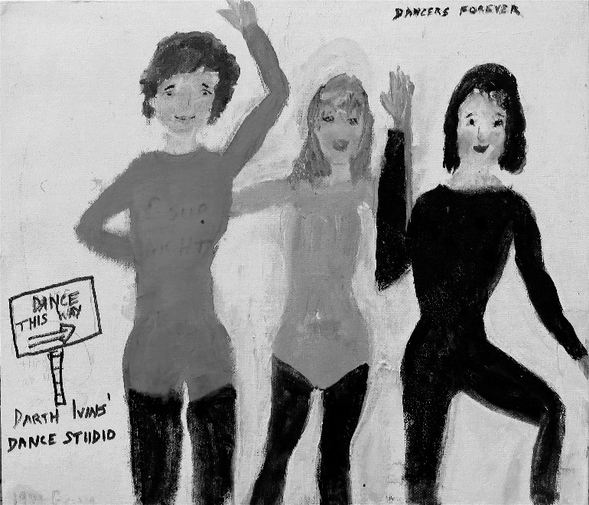

About the Author

From a shy introverted high school and college girl, Gyana morphed into a somewhat radical “peacenik.” Around 1974 or 75 her life took a turn. She was divorced, remarried, went back to school for a family therapy degree, and lived in a woodsy canyon north of Claremont, California with her husband and her two children. In addition to counseling practice, she did a lot of clay work in these years that kept her grounded.

She also traveled to India and stayed for long periods of time. For a while she lived in a commune in Oregon that was connected with a beloved spiritual teacher. Time glided on. She moved to Santa Fe, New Mexico and, eventually, north to Taos, where she now lives. She says, “The beauty of this land never fails to thrill me. I offer these poems to you, hoping we will lift each other up, you in the beauty of the words, and me in your response of appreciation and love for poetry. Poetry may offer us a viewpoint that is rarely found anywhere else. Maybe the light is brighter and illuminates everything.”